Naïve Bayes Classifier

David Graves
Colorado State University Global
CSC510
Dr. Bingdong Li
October 15, 2025

Naïve Bayes Classifier
Naïve Bayes Classifiers have become one of the go-to algorithmic approaches for predicting and categorizing data in machine learning applications. When used correctly they can make sense of limited data sets and can be effective when you’ve got lots of features to sort through. One additional great benefit for using these types of classifiers is that it, “Scales well: Compared to logistic regression, Naïve Bayes is considered a fast and efficient classifier that is fairly accurate when the conditional independence assumption holds.” (IBM, 2025) The term Naïve Bayes Classifier encompasses a handful of different approaches that can be deployed based on the input data on hand. If you have continuous values you, can you a Gaussian Naïve Bayes distribution, if you’re looking for the frequency of a term in a document you’d want to use Multinomial Naïve Bayes, and Bernoulli Naïve Bayes approaches deal with binary features in a data set. The key to this is that they all can take different types of data, train, and accurately predict what a future data point might be based off user input. For this exercise I’ve created a program that can predict what animal (cat, dog, rabbit, bird, snake, bat, turtle) should be returned based on three input factors; Has fur, Lays eggs, Can fly. Since, “there may be multiple features, but each one is assumed to be a binary-valued (Bernoulli, boolean) variable” (Scikit-Learn, 2025) the Bernoulli approach should be the correct path to take. By using the ‘BernoulliMB’ implementation from the scikit-learn Python library I was able to leverage frequency tables to calculate the posterior probability internally without having to explicitly code this. This tool also computes the likelihood table by finding relevant probabilities internally during training. Explicitly in the code I used ‘clf.predict()’ to compute the posterior probability for each class and was again able to lean on the basic features of ‘BernoulliNB’ to correct zero probability errors using Laplacian correction. You’ll find images of the algorithm code in images 1 and 2 below and program execution in image 3.
Directions for Program Execution
I’ve included the file ‘Naïve_Bayes_Classifier.py’ which can be executed by running the program and keying in values for the three questions to which the program should respond with an appropriate guess.
Image 1
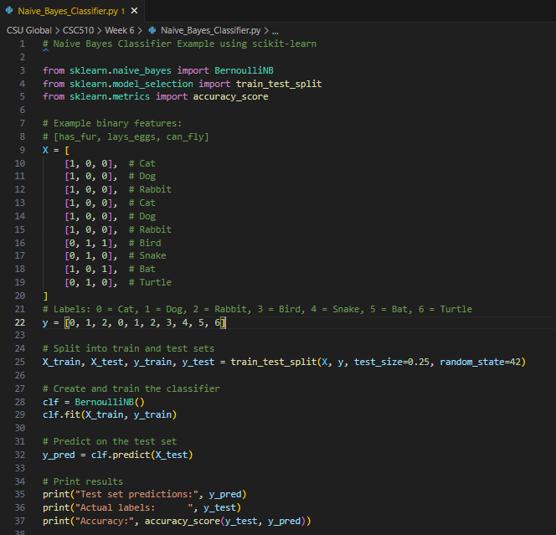
Image 2
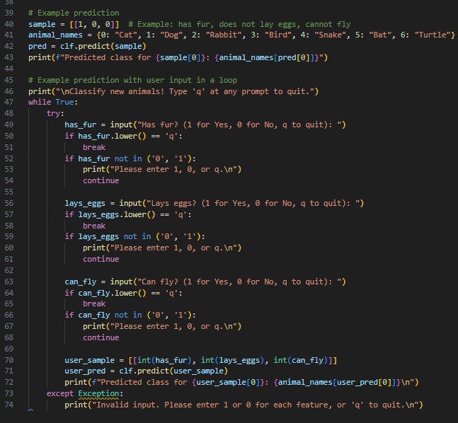
Image 3
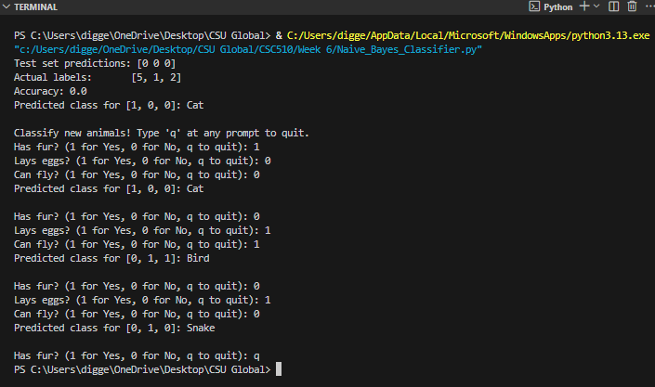
References
Scikit-learn (2025). Scikitlearn.org. Stable/Modules/Naïve Bayes/Bernoulli Naïve Bayes.
https://scikit-learn.org/stable/modules/naive_bayes.html#bernoulli-naive-bayes
IBM (2025). IBM.com. Advantages and disadvantages of the Naïve Bayes classifier.
https://www.ibm.com/think/topics/naive-bayes

